# 实验1：创建DHCP服务器

**注意事项：DHCP服务器必须手动设置IP多种**

**192.168.7.10**

**1.客户机测试：**

**1）win10**

**2)Centos7**

**dhclient -d**

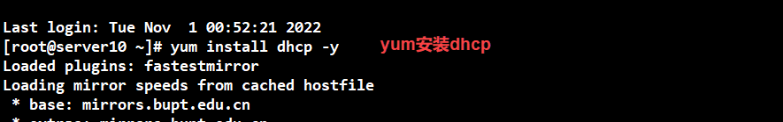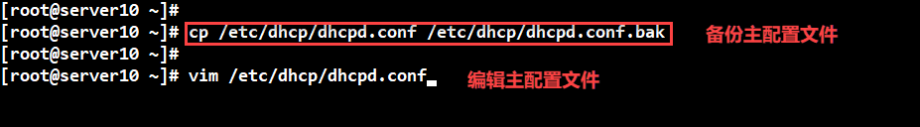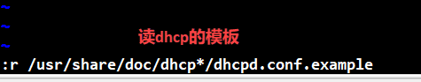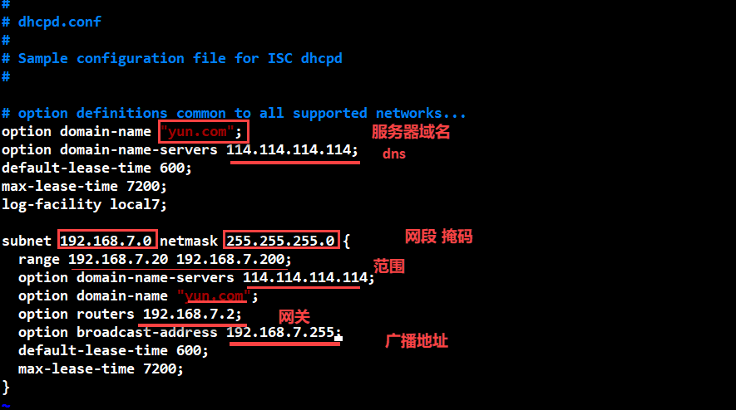

**然后systemctl start dhcpd 开启dhcp**

**Systemctl enable dhcpd 开机启动**

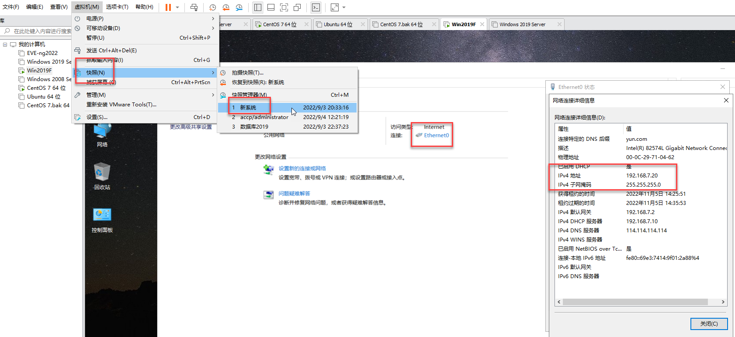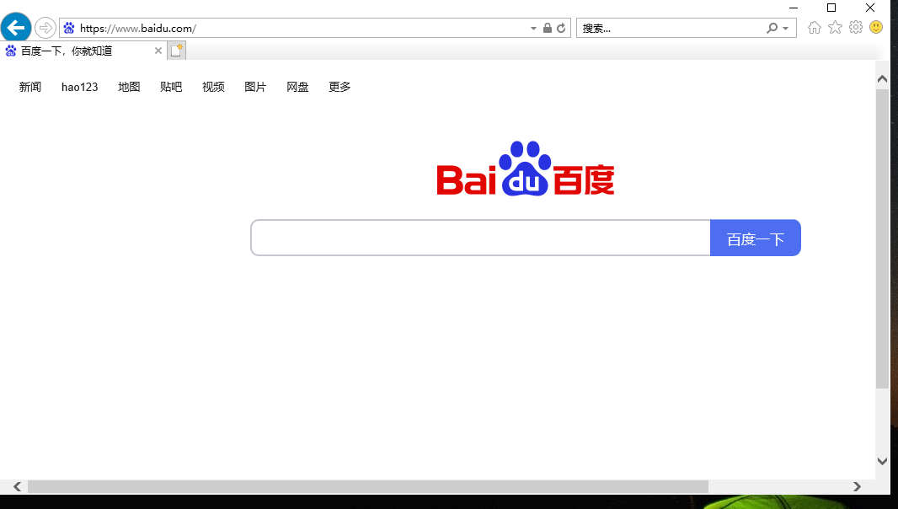

**2.给服务器分配指定IP地址**

**win2019**

**192.168.10.88**

**物理地址. . . . . . . . . . . . . : 00:0C:29:1E:D4:14**

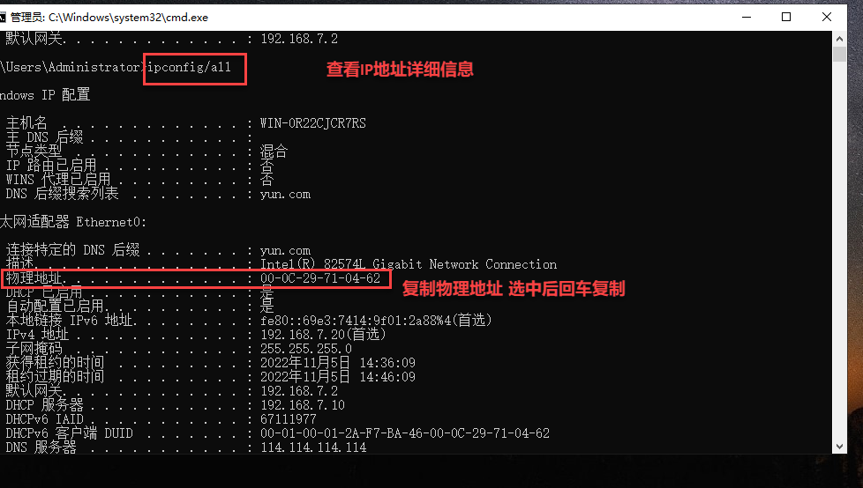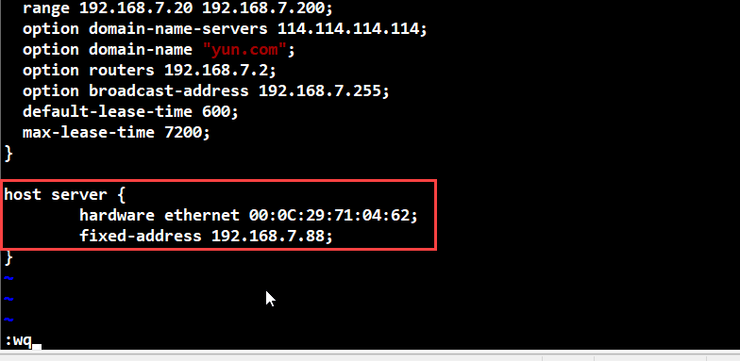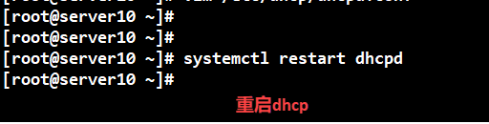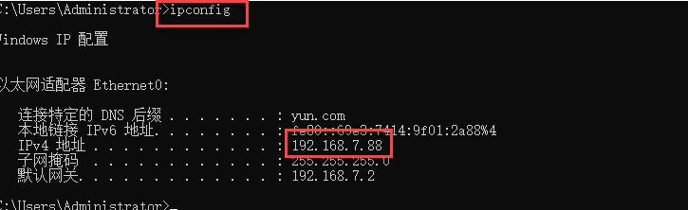

-----------------------------------

# 实验2：Centos7 DHCP服务器+华为三层交换机中继代理

**1.在centos7安装和配置DHCP,并划分5个网段**

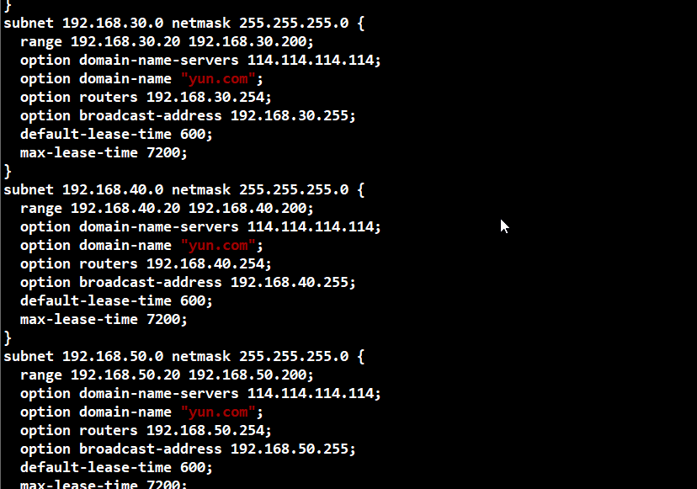

subnet 192.168.10.0 netmask 255.255.255.0 {

range 192.168.10.20 192.168.10.200;

option domain-name-servers 114.114.114.114;

option domain-name "yun.com";

option routers 192.168.10.254;

option broadcast-address 192.168.10.255;

default-lease-time 600;

max-lease-time 7200;

}

subnet 192.168.20.0 netmask 255.255.255.0 {

range 192.168.20.20 192.168.20.200;

option domain-name-servers 114.114.114.114;

option domain-name "yun.com";

option routers 192.168.20.254;

option broadcast-address 192.168.20.255;

default-lease-time 600;

max-lease-time 7200;

}

subnet 192.168.30.0 netmask 255.255.255.0 {

range 192.168.30.20 192.168.30.200;

option domain-name-servers 114.114.114.114;

option domain-name "yun.com";

option routers 192.168.30.254;

option broadcast-address 192.168.30.255;

default-lease-time 600;

max-lease-time 7200;

}

subnet 192.168.40.0 netmask 255.255.255.0 {

range 192.168.40.20 192.168.40.200;

option domain-name-servers 114.114.114.114;

option domain-name "yun.com";

option routers 192.168.40.254;

option broadcast-address 192.168.40.255;

default-lease-time 600;

max-lease-time 7200;

}

subnet 192.168.50.0 netmask 255.255.255.0 {

range 192.168.50.20 192.168.50.200;

option domain-name-servers 114.114.114.114;

option domain-name "yun.com";

option routers 192.168.50.254;

option broadcast-address 192.168.50.255;

default-lease-time 600;

max-lease-time 7200;

}

2.在二层交换机配置接入链路和中继链路

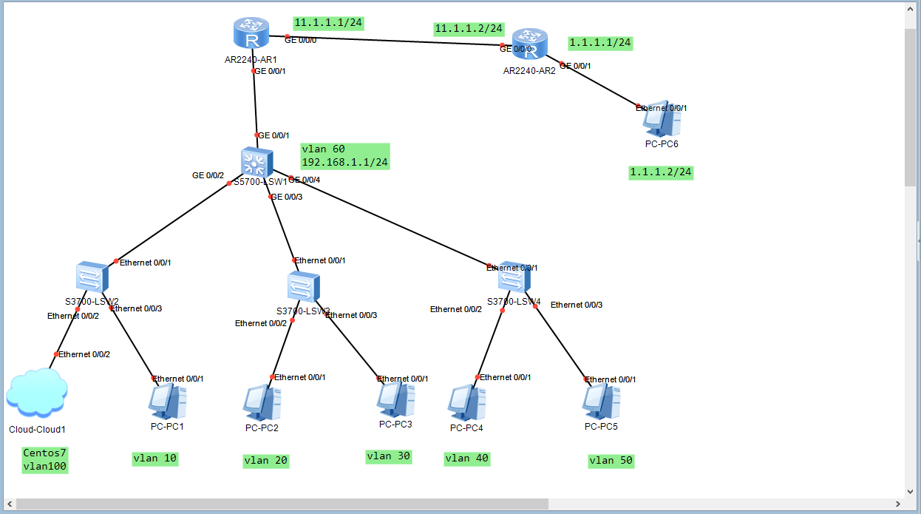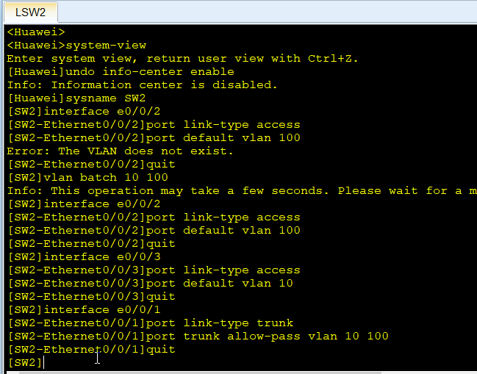

3.在三层交换机配置三层交换和DHCP中继代理，注意三层交换机要开启DHCP

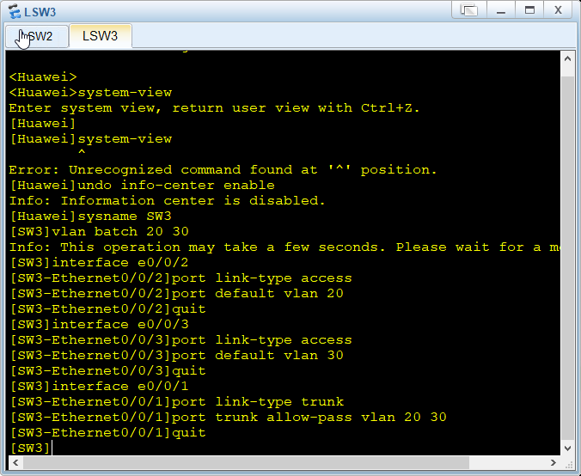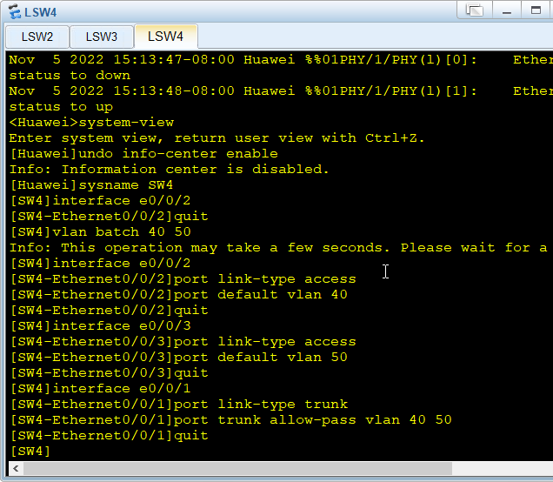

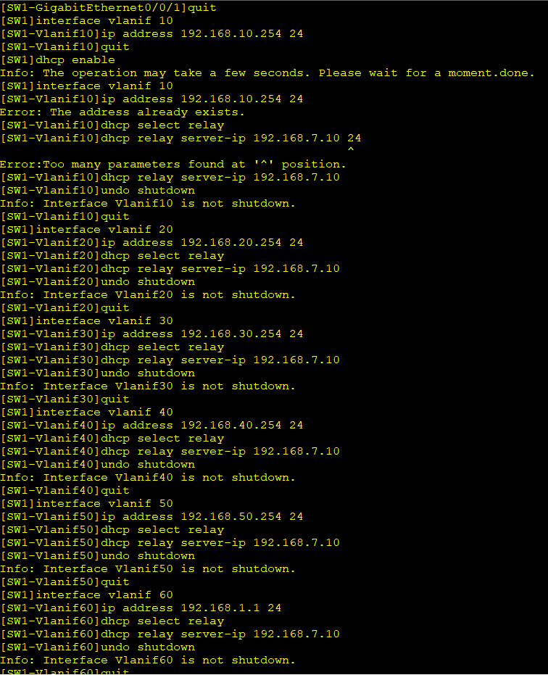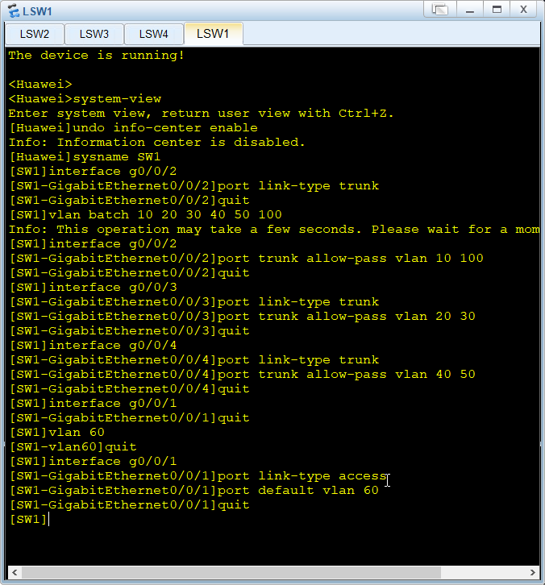

3.在三层交换机配置默认路由

4.在路由器配置默认路由和静态路由